

Product Brief:
Contact Communications Logging (CCL)

Toll Free (North America) 1 866 751 2130  Fax 613 567 9982  www.leapbeyond.com

What is Contact Communications Logging?
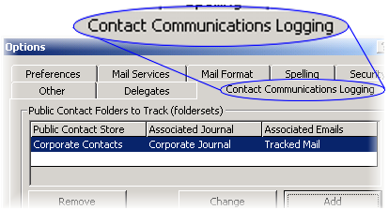
CCL is an add-in for Microsoft Outlook that allows a company to keep track of email and other communications with their clients, and easily share the retained information across the enterprise.
It works in a similar fashion to the Outlook Journal, but uses public instead of private folders.

Features
- runs within the Outlook / Exchange framework
- automatically logs email sent by employees and appointments they make
- places five buttons on the toolbar which appear when a tracked contact is selected, providing fingertip access to creation of phone conversation notes, file links, and other journal entries

- saves email and journal entries in public folders
- quickly see all conversations with a contact from the Activities tab in Outlook
- multiple tracked folders can be set up with Exchange security so that communications with confidential contacts are tracked securely

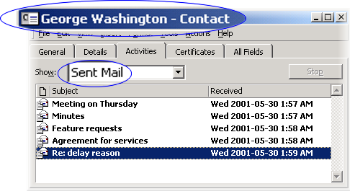
Popular Uses
- consulting firms that track all communications with their clients for legal auditing purposes
- human resource departments wishing to retain a log of applicant progress through the phases of hiring
- support centres that need instant access to the last communication with a customer, even if the previous conversation was with another call centre

Requirements
Microsoft Outlook 2000 with Service Release 1a (or greater) or Outlook 2002 (XP) must be installed in Corporate / Workgroup Mode on each workstation that will utilize Contact Communications Logging. Leapbeyond Solutions does not recommend using Office SR2 with this product at this time.

Purchasing
A free trial version can be obtained at www.leapbeyond.com/software. While locked, it is limited to 40 uses. CCL unlock keys may be purchased online. Visit today for the latest pricing.

This document is current as of October 2002. All information, including pricing, features and requirements, is for informational purposes only, and subject to change without notice. Leapbeyond Solutions makes no warrantees as to its accuracy and will not be held liable for damages resulting from its use.

